Blue Jackets, Bright Futures
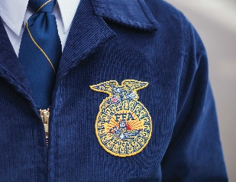
Max FFA Jacket Application
Jackets sponsored by the
Duane & Lynae Schroeder Family, the Danny & Annie Lies Family, Gertrude Scheresky
Due: February 1st, 2025
-The purpose of this application is to provide members with the opportunity to earn a new FFA jacket.
-This opportunity is made possible through generous sponsors of the Max FFA Chapter.
-Contact Mrs. Huettl with any questions.

Directions: Complete the application below. All applications must be typed. Applications can then be printed and turned in to the Max Agricultural Education Department. The application can also be found on the AET under “portfolio” on the left side of the page. Applications MUST be typed.

Name: _______________________________
(First and Last-How it will appear on your FFA jacket if you are a jacket winner.)

Chapter Name: Max FFA

Jacket Size (male or female style): _________________

1.What FFA activities have you participated in since becoming an FFA member? (Minimum of 5 sentences.)

2. Why do you want an FFA jacket? (Minimum of 5 sentences.)

3. What is your favorite part of the FFA creed and why? (Minimum of 5 sentences.)

4. What are your future FFA goals? (Minimum of 5 sentences.)

