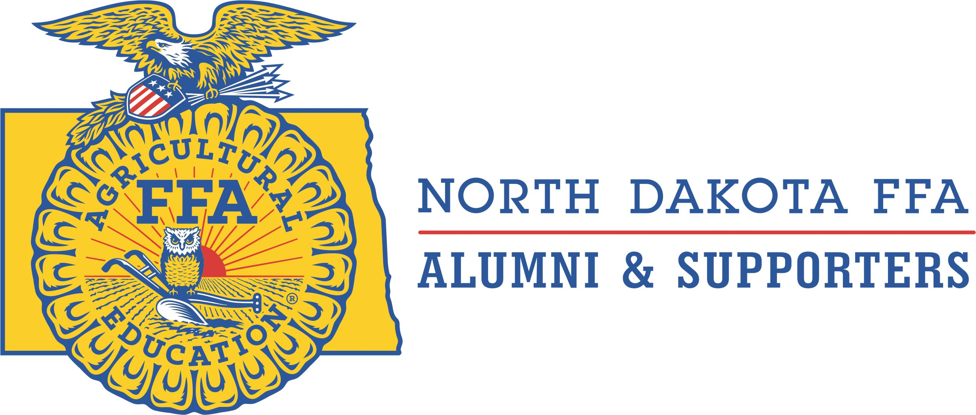
NORTH DAKOTA FFA ALUMNI & SUPPORTERS

2025 SENIOR COLLEGE/TRADE SCHOOL SCHOLARSHIP APPLICATION

This $500.00 scholarship is available to any senior FFA member

graduating from high school Spring 2025.

Applicants must be from a FFA chapter who has a local FFA Alumni chapter in their community.

DUE DATE: 11:00 PM CST March 10, 2025.

Name

Address
City, State

& Zip Code

Cell Phone

Email Address

High School

Last attended
Parent/

Guardian Name

College

University or
Trade School
Attending

FFA PARTICIPATION:

Number of years enrolled in Agricultural Education in High School

Name of Agricultural Education teacher(s)

Highest FFA degree currently held

List your top FFA activities and/or FFA Awards received and if it was awarded at the Chapter, State or National level.
(Examples: District Leadership Conference, State Convention, National Convention, State Fair, Winter Leadership, other)

NON-FFA ACTIVITIES & AWARDS: List your achievements in the following areas:
School Activities besides FFA:

Community Involvement and Volunteer Hours:

IN LESS THAN 300 WORDS, DESCRIBE HOW AGRICULTURAL EDUCATION HAS MOLDED YOU INTO THE PERSON YOU ARE AND THE CAREER PATH YOU HAVE CHOSEN:

By checking the box I confirm I will be attending the above listed college, university or trade school in the fall of 2025.

Email Applications To: Bruce Bachmeier: alumnipresident@ndffa.org and
Dan Spellerberg: alumnisec-treasurer@ndffa.org
by 11:00 PM CST March 10, 2025

If you have any questions, please email Bruce Bachmeier: alumnipresident@ndffa.org

